AUTHOR:ABDUL BASEER

Linux Challenge for DevOps Students
Objective:
The objective of this challenge is to assess the students' ability to manage a Linux environment effectively, write shell scripts, and perform system administration tasks. They should be able to demonstrate their understanding of Linux file system hierarchy, user management, process management, networking, and automation.
Challenge Tasks:
Beginner Level
Task 1: Basic Linux Commands
1. Create and Navigate Directories:
o Create a directory structure as follows: /home/devops/academy/project. 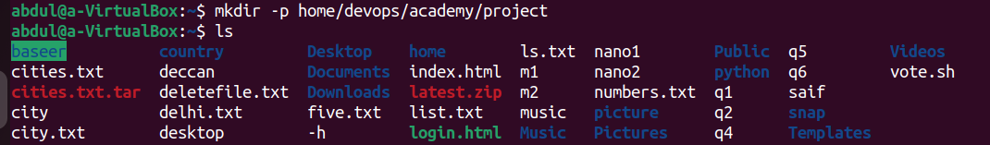o Navigate into the project directory.
2. File Management:
o Create an empty file named README.md inside the project directory. o Create another file named notes.txt and add the text "DevOps Linux Challenge" into it.
o Copy notes.txt to /home/devops/academy/backup/. 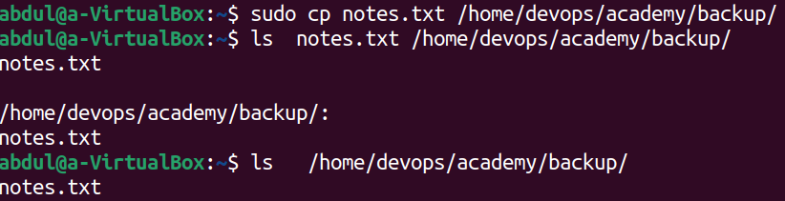
3. Permissions:
o Change the permissions of README.md to be readable and writable only by the owner.
o Make notes.txt readable by everyone, but writable only by the owner. 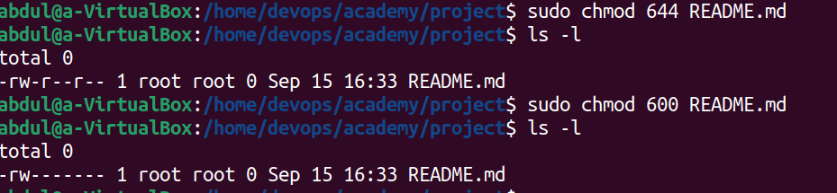Task 2: User and Group Management
1. Create Users:
o Create a new user named student1.
o Set a password for student1. 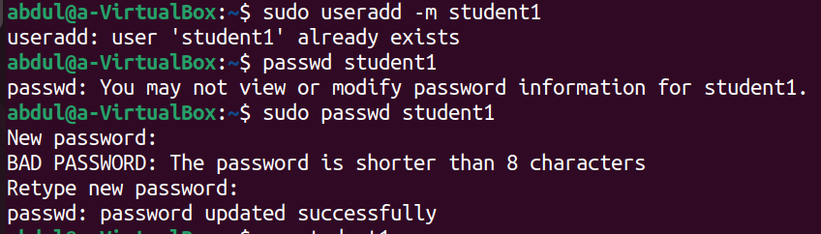
2. Groups:
o Create a new group named devops.
o Add student1 to the devops group. 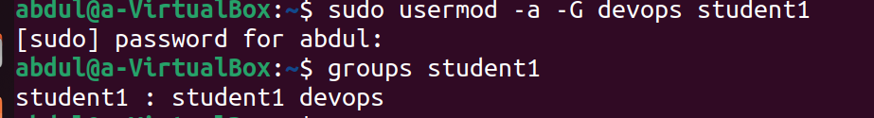
3. User Permissions:
o Ensure that the project directory is accessible to members of the devops group. 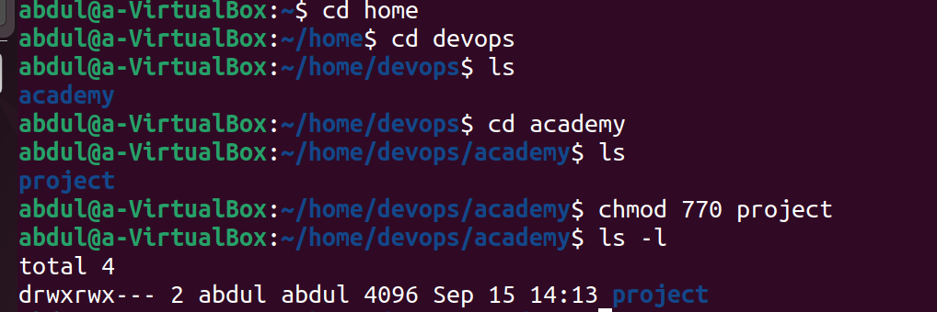
4. Disk Usage:
o Display disk usage in human-readable format for /home directory and save the output to a file named disk_usage.txt. 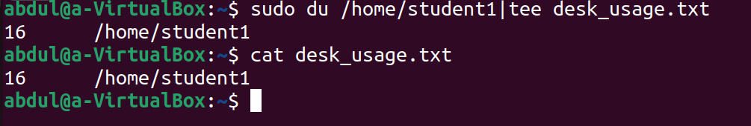
Intermediate Level
Task 3: Process Management
1. List Processes:
o Display all running processes and redirect the output to a file named process_list.txt. 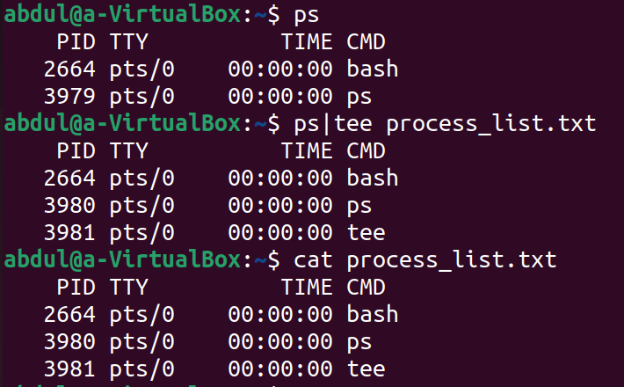
2. Background Process:
o Start a simple background process that writes the current date and time to a file named timestamp.txt every minute using a while loop and sleep. 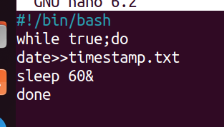
3. Kill Process:
o Find the process ID (PID) of the background process started in the previous step and terminate it. 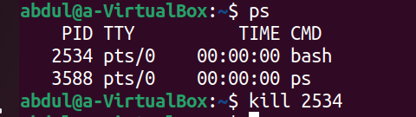
4. CPU and Memory Usage:
o Display the current CPU and memory usage using top or htop, save a snapshot of this information to a file named cpu_mem_usage.txt. 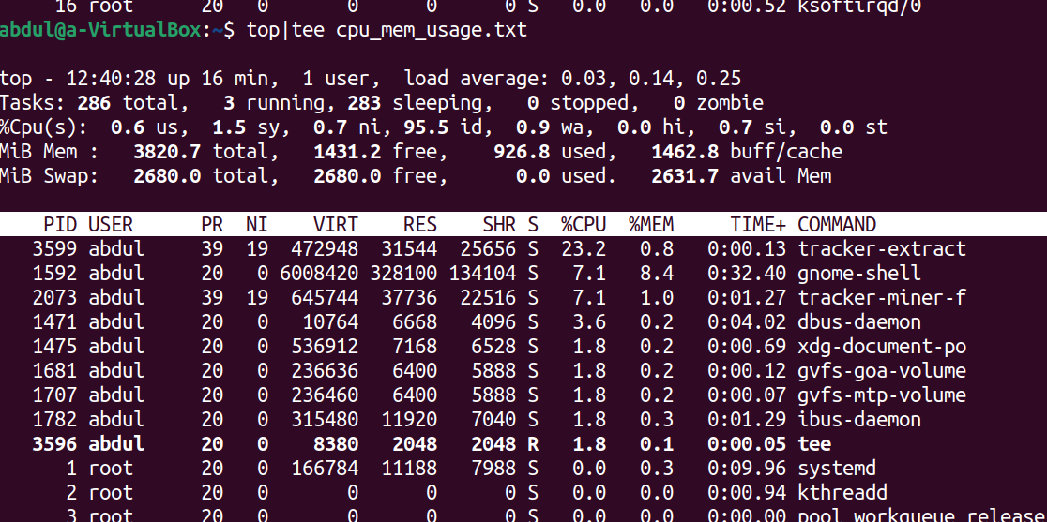
Task 4: Networking
1. Network Configuration:
o Display the current network configuration using ifconfig or ip addr. 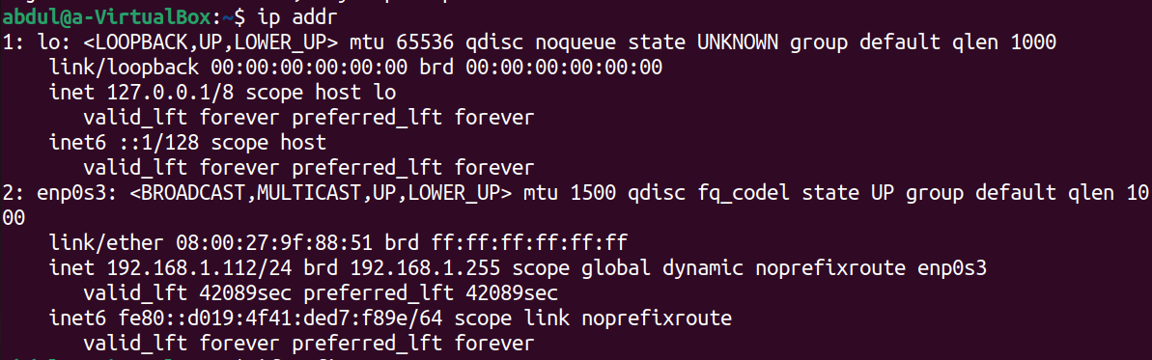2. Ping Test:
o Ping google.com and save the output to a file named ping_results.txt. 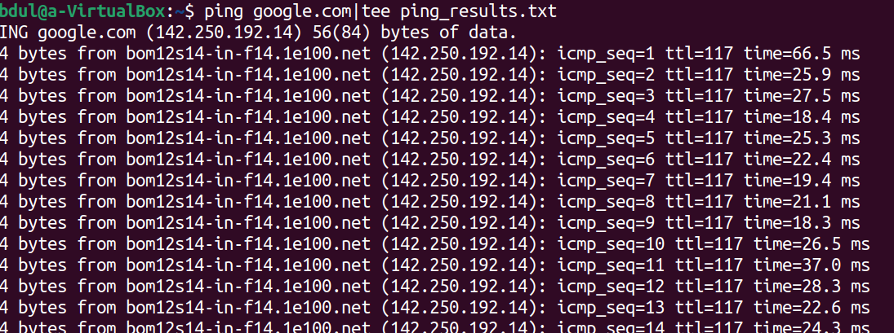3. Open Ports:
o List all open ports on the system using netstat or ss command. 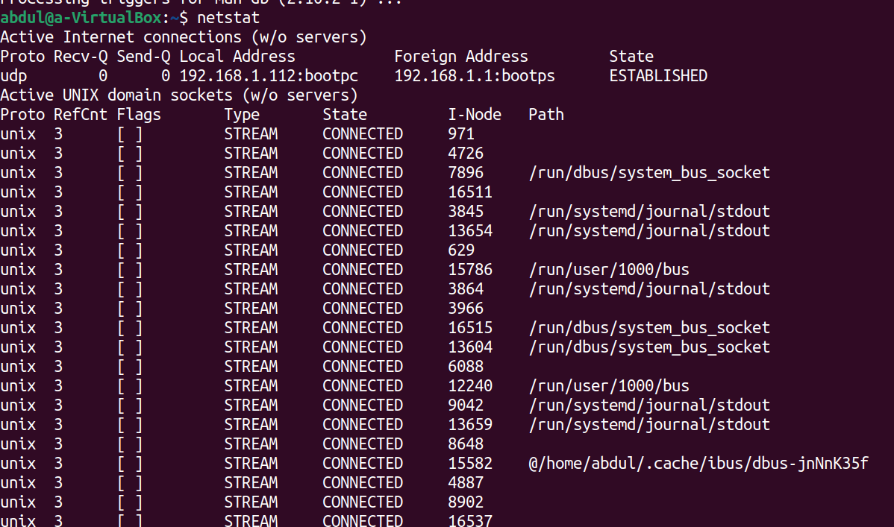
4. Firewall Configuration:
o Check if the ufw (Uncomplicated Firewall) is installed and running. If not, install and enable it.
o Allow incoming connections on port 80 (HTTP) and 443 (HTTPS). 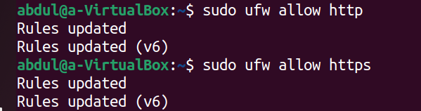Task 5: Shell Scripting
1. Backup Script:
o Write a shell script named backup.sh that compresses the project directory into a tar.gz file and saves it in the /home/devops/academy/backup directory. The script should include error handling to ensure the backup only proceeds if the project directory exists. 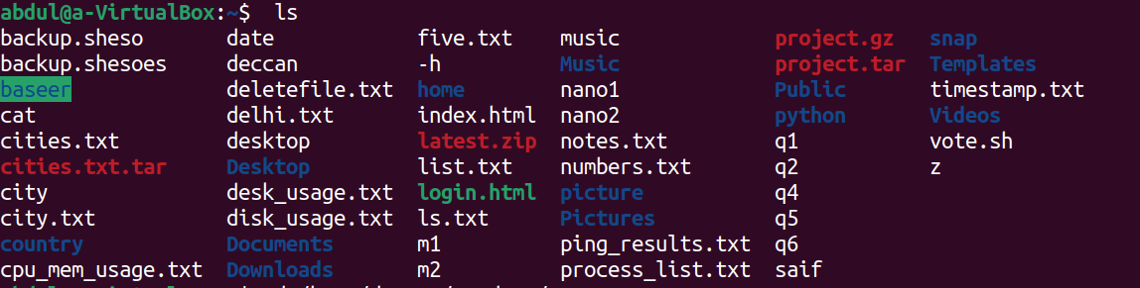
2. Automation Script:
o Create a script named cleanup.sh that deletes all files in the
/home/devops/academy/backup directory that are older than 7 days.
Schedule this script to run daily using cron. 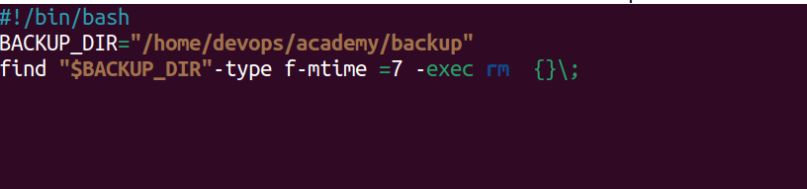
3. Log Rotation:
o Write a script named rotate_logs.sh to rotate the timestamp.txt file if it exceeds 1MB in size and save old logs with a timestamp in the filename. o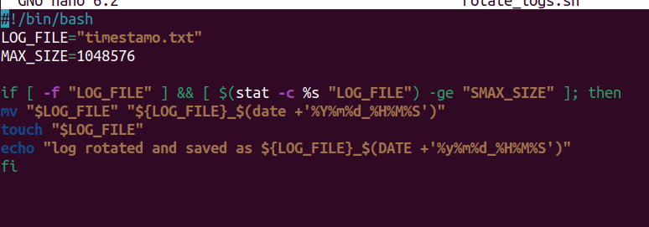
Advanced Level:
∙ Advanced Shell Scripting:
∙ Write a script named resource_monitor.sh that:
o Monitors CPU, memory, and disk usage.
o Logs usage data every 5 minutes to a file named resource_usage.log. o Sends an alert email if CPU usage exceeds 80% or available disk space falls below 20%.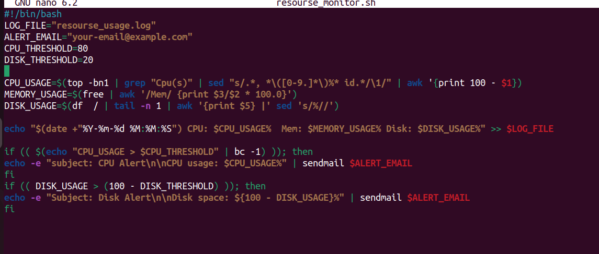
∙ User Management Automation:
∙ Write a script named bulk_user_add.sh that:
o Reads a list of usernames from a file named user_list.txt. o Creates each user and sets a default password.
o Adds each user to a specific group (e.g., students).
o Ensures each user has a home directory created.